

MAC
BUDAPEST CHILDREN’S
ICE HOCKEY CUP

(29 evening) 30-31 January, 2016.

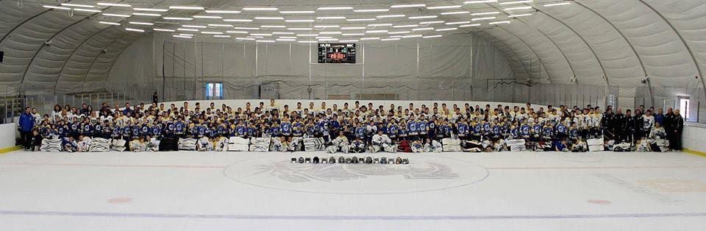

Dear Sporting Friends,

MAC Hockey Academy Budapest is delighted to announce the 1st MAC INTERNATIONAL CHILDREN’S ICE HOCKEY CUP to be held on 29-30-231 January, 2016. We kindly extend our invitation to your team for this cup and hope you will be able to join this wonderful event especially put together for children.

MAC Hockey Academy Budapest is Hungary's oldest and largest hockey club. The goal of MAC is to make hockey available for everyone, as we believe that all has the potential within to become a hockey player on a level suitable for the individual. As part of this nurturing path we think it is important to give our youth level players the opportunity to play in an international setting, to try themselves out against foreign teams. The cup was designed to serves as a motivation as well as a 3 day celebration of hockey for all participants.

Below please find the major details of the cup.

DATE:
29-30-31 January, 2016.
LOCATION:
- Tüskecsarnok (Spike Sport Hall) Budapest, Magyar tudósok körútja 7., 1117
- GPS coordinates: 47°28’17.71” N ; 19°03’28.12” E
(see map attached)

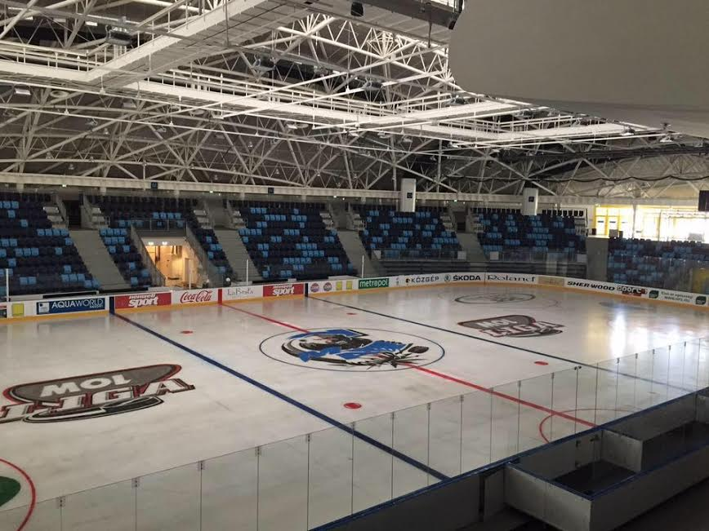

CUP SPECIFICATIONS:
- 8 game minimum
- 1 game: 15 minutes period length, twice
- Official cup regulations will be sent upon application

ELIGIBILITY:
- Eligible players are sole teams with boys/girls born in the year 2006 or younger (U10)
- Guest players and over-age players will not permitted to take part. The minimum amount of players required is twelve and one goalie
REGISTRATION:
- Please send us your application to participate at the cup by filling out the attached registration form, signed by your team’s president and return to bpmacihc2016@gmail.com. Your registration will be considered final if sending the registration fee.
REGISTRATION FEE:
- EUR 200 per team; please transfer the registration fee to the following account. When transferring the fee please e-mail us your proof of transfer to: bpmacihc2016@gmail.com. We ask you to please include in the memo section of your transfer your team name and the name of the event: MAC Budapest Children’s Ice Hockey Cup, 2016
MAC Budapest Jegkorong Akademia , OTB Bank: 11714006-20450452
- The fee covers the cost of the opening ceremony to be held on the first evening of the cup (29 January 2016), lunch on the days of 30-31 January at the event site, fruit and water during the cup for the entire team and trainers
- Furthermore the fee covers prizes to be given to the : winner team, best player of the cup, best goalie of the cup, fair play prize, and the challenge cup

TRANSPORTATION:
- Further information to be given m upon request
ACCOMMODATION:
- Further information to be given upon request

CONTACT INFORMATION:
In case you have any questions or need further information on the cup please send us an e-mail to:
bpmacihc2016@gmail.com

